Chase Williams

Mr. Andy Stallard

Journal

Fall 2021

**September 5th – 11th:**

The Algorithm

* The problem: The accuracy of the OCR device will rely on the algorithm we use in addition to any machine learning we incorporate. I will focus on coming up with an algorithm that will determine what letter is being shown on a license plate.
* Why this is a problem: We currently do not have a method for detecting text in an image and need to find a way to accomplish this in order for our project to succeed.
* How I am planning to solve this: I will convert the picture to a matrix for each letter and comparing the picture matrix to matrices of the same letter to see if the matrices are similar.

Finding a project idea for a product

* The problem: Coming up with an idea for a product to work is challenging due to various limitations we have as a group.
* Why this is a problem: For one, we can only think of problems that we have or have seen others have which is a miniscule subset of all the problems in the world that we might be able to solve. In addition, many of the ideas we thought of did not work well for our mix of engineering disciplines as well as the number of members in our group.
* How this problem was solved: I raised my hand in class to indicate that our group would like to set up a meeting with the instructor, who helped us come up with an idea in that meeting that we settled on.
* Lesson learned: It would have been beneficially to have met with the professor a week prior to see if he had any ideas for our group.

**September 12th – 18th:**

The automated license plate reader

* The problem: Some of the individuals in the group did not like aspects of the automated license plate reader that we were planning to create, specifically in how it infringes on people’s privacy.
* Why this is a problem: If we would have decided to make this device, some in the group would have felt like they were making a product that did not align with their values.
* How this problem was solved: I came up with an idea for a automated license plate reader detector that will document each time you come across one of those devices while driving, so you can know when pictures are potentially being taken of your license plate.

Communication about the Evergy QR code project

* The problem: We did not receive all the details about what we would work on for the QR code Evergy project since we learned about this idea from a third-party.
* Why this is a problem: We were not able to understand all the intricacies of the project, which led to us presenting only one aspect of it. This one aspect was not approved as a project in class, which caused us to spend time thinking of other ideas.
* How I am planning to solve this: We scheduled a meeting with Evergy to gather more information about that project. In addition, we have had discussions as a group about other project ideas.

**September 19th – 25th:**

Data for the Evergy QR code project

* The problem: After our meeting with some of my Evergy coworkers, I learned that they would most likely not be able to provide us enough item maintenance data for the QR code project.
* Why this is a problem: This means that we would not be able to work on the project idea since the item maintenance data would be critical to its success.
* How this problem was solved: I was able to come up with another project idea that we have decided to work on. This idea involves creating a device that would display the keyboard position of one’s fingers on the their computer screen, so that individual would not need to constantly switch their gaze back and forth from their keyboard to the screen if they cannot touch type.

ALPR detector Idea

* The problem: I conducted some research to learn about how we could collect the data needed for the ALPR detector idea and found that there may not be that many ALPRs in Wichita that we could easily spot. I found an article from the end of 2020 that explained there were 35 of these devices being newly installed in Wichita. Our best bet might have been to get our training data from Google maps, which is a huge risk because of there being no definite way to find the devices.
* Why this is a problem: Without being able to spot ALPRs out in the real world, we would not be able to test our device.
* How this problem was solved: I came up with the previously mentioned idea for a device that can display one’s keyboard finger positioning on a computer screen.

Having the product’s user be its creator

* The problem: Understanding what exactly your target market needs from your device can be challenging if you cannot directly contact them.
* Why this is a problem: If you do not know what your user will need, your design and its requirements will mostly likely be wrong in some way. Also, you could waste time looking for users to contact.
* How this problem was solved: I came up with the idea for the keyboard finger positioning display device because this will solve a problem that I personally experience. If the group has questions about the requirements and design of the device, I will be a valuable resource. Consequently, it is beneficial to have the creator of a product also be its target user.

**September 16th – October 2nd**

Market Research

* The problem: In the previous weeks’ journal entry, I mentioned that I would be a valuable resource for helping the group come up with requirements because I experience a problem this device can solve. However, while common sense tells me that others might experience the same problem, I do not have any evidence to prove this.
* Why this is a problem: If we cannot prove that there is a large enough market that is experiencing problem we are solving, we might create a device that no one will use.
* How I am planning to solve this: I will conduct online market research to discover a market that could use the product we are making. I am choosing to research online instead of sending out a survey due to it not being likely that we would receiving enough responses to make it worthwhile. I am assuming our target market would be elementary school children and the elderly.

**October 3rd – 9th**

Capacitive touch implementation

* The problem: I am wanting to figure out a way to add the capacitive touch feature to the keyboard without needing to buy metal keys.
* Why this is a problem: If we need to buy metal keys, this will add complexity to our design because we will need make sure that the metal keys are compatible with the keyboard. If we were to cover the keys with metal as an alternative, that would lower the aesthetics of the keyboard. Lastly, if we were to just add metal on the tops of the keys, we would need a wire extending from the top of each key to the captative grid below. This also will lower the aesthetics of the keyboard if you have 40+ wires showing.
* How this problem was solved: I conducted some research on an Arduino capacitive touch sensor and found out that they can detect a change in capacitance even if your finger is not touching metal that is connected to the sensor. Furthermore, even if there is a nonconductive barrier covering the sensor, they can still measure a change in capacitance. Based on this, we should be able to add metal under the key, have a wire connected to this metal and the metal grid below, and connect the metal grid to the inputs of the capacitive sensors. Once this is done, when a finger approaches a nonmetal key, the sensors should detect a change in capacitance. I have added a picture I drew of this solution.

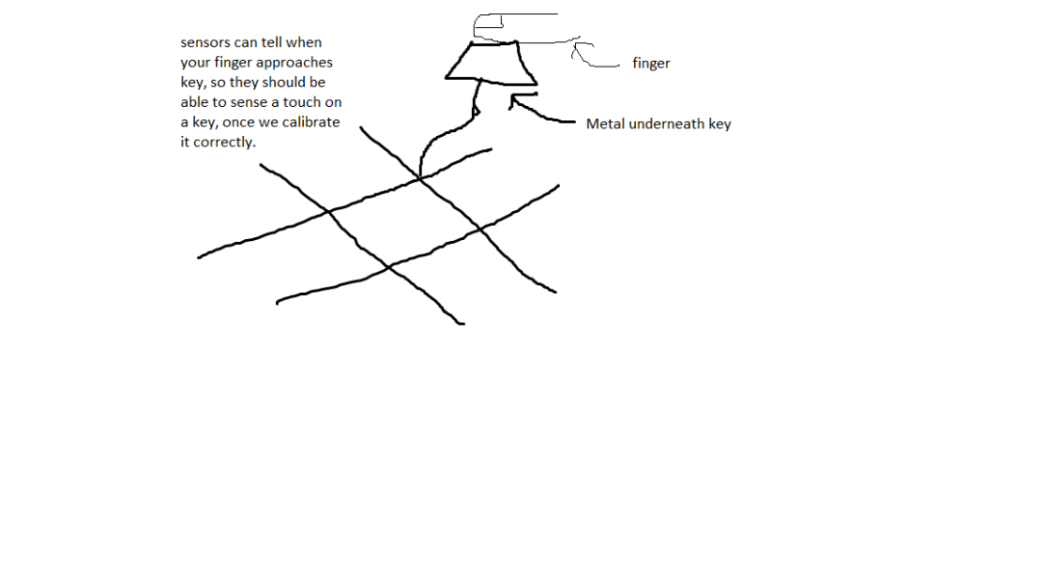

**October 10th – 16th**

* The problem: After conducting market research so that we could focus on solving one problem for a specific group, I could not find enough conclusive evidence that there is a group that would need our device. The closet I came to this is figuring out that the visually impaired (old and young) would benefit from seeing larger keys with better contrast on a screen.
* Why this is a problem: I want to have an idea of the exact problem we our solving to avoid needing to change our design to solve a different problem than we were expecting when it is too late.
* How I am planning to solve this: I contacted Mr. Stallard, who helped us understand some of the potential applications of our technology. One application was giving the keyboard some of the same functionality of a mouse, and the other was to change the letters on the screen keyboard keys to match the language the user is comfortable with. To help finalize our market research Mr. Stallard suggested we contact Disability Services and CPRF to find users for our product. I plan on contacting them to see what problems those with disabilities experience that can be solved by our device, which will help me complete the market research.

**October 17th – 23rd**

* The problem: My attempts to reach out to organizations to see how we can help them have not amounted to us getting in contact with right the decision-makers for this in most instances. I called CPRF twice, and most of the conversations we had centered around them trying to help figure out who to send me to. When they would send me to the contact that might be able to assist, that individual would not be available at the time. Consequently, I left voicemails but received no responses. I tried calling the National Federation of the Blind multiple times and left an email but did not receive a reply. Finally, I contacted Disability Services here at Wichita State and got in touch with the right decision-maker. However, the main suggestion that I received was to create a memo to send to those who use the services of this group, asking if our product can help them. I have seen another student send an email to a large group of students and only receive one reply, so I did not like this option.
* Why this is a problem: If we cannot get in contact with our target market, which is those who are visually impaired, we cannot get confirmation that our product solves their problem.
* How I am planning to solve this: An individual with CPRF recommended that I reach out to Envision, which is an organization that specifically helps those with low vision. I plan to get in touch with this organization to see if they would be interested in our project.

**October 24th – 30th**

* The problem: I have not been able to get in touch with our target audience.
* Why this is a problem: As mentioned in the previous week’s entry, we want to get the user’s input on our device to make sure we are building something that actually helps them.
* How I am planning to solve this: I reached out to Envision to see if we can work with their organization and those with low vision. In addition, I researched how we can give some extra functionality to our product to see if we can solve other problems besides what we were originally planning to solve. One problem that some with disabilities may have is a difficulty with using the computer mouse. I looked into ways to give the keyboard some mouse functions and found out we can do this using technology we are familiar with: an Arduino microcontroller and the Arduino mouse library. However, after thinking about this solution, I realized it is not that much different than what a touchpad offers. Also, there is already a way to control the mouse with keys on the keyboard for Windows devices.

